Updated version
Esgair Galed Community Liaison Group notes 14 May 2025
Attendance:
Derrick Pugh – Trefeglwys Community Council
Elwyn Vaughan – County Councillor
Meilir Jones – Cadfarch Community Council
Eluned Lewis - Community Investment Manager, Bute Energy
Huw Rees – Esgair Galed Energy Park Project Manager, Bute Energy
Kadun Rees - External Affairs Coordinator, Bute Energy

- Introductions

- Discussion on the formation of the Community Liaison Group for the Esgair Galed Energy Park.
- Discussion on the purpose of the group was decided as follows:
  - Provide a communication channel between Bute Energy representatives and the local community to address any issues as they arise.
  - Provide a forum for discussion and exchange of information.
  - Receive updates on the planning process from Bute Energy.
  - Receive information on the community investment package and provide information to inform the community mapping approach used to identify community priorities.
- It was decided that future meetings would be in person, but there would be an option to join online for those who cannot travel. Therefore, Bute Energy will ensure the correct equipment for future meetings to facilitate hybrid meetings.
- The group will trial the next meeting as a hybrid meeting with the face-to-face contingent in Staylittle Community Hall.
- Expectations for the group and future meetings:
  - Notes will be taken by the project team and will be distributed to members following meetings.
  - Members can pass information on to their constituents.
    - Bute will share minutes on project website
    - Trefeglwys Community Council will make a separate page on their website.
    - The group agreed to publish information from the group in local newspapers like Blewyn Glas.
  - Need a minimum of 6 members for the group to conduct a meeting.

  - Non-attendance for three consecutive meetings by any member will be discussed by the other CLG members and could result in their membership being withdrawn.
  - Although members will have different opinions on the Esgair Galed Energy Park project, members will conduct themselves appropriately and share information from the group to their constituents/members of the bodies they represent.
- The group briefly discussed upcoming shows and community council meetings, for awareness and to plan future meeting dates. These were identified as follows:
  - Sioe Trefeglwys – Saturday 2nd August
  - Trefeglwys Community council meeting: 4th Tuesday of each month
  - Aberhosan Show - 3rd Thursday of August
- Bute Energy would like to bring their lead for social mapping to the area to collect quantitative and qualitative data to inform the top place-based challenges, i.e. the main priorities and challenges facing communities. This information will help inform Community Benefit Fund priorities.
- A discussion on widening the membership was had then. The group discussed local organisations, groups and other interested parties. They came to a decision on initially inviting the following:
  - Elected members: Cllr Gary Mitchell, Cllr Glyn Preston, Cllr Elwyn Vaughan, Cllr Gareth Morgan.
  - Community Councils: up to 2 members from each community council can attend.
    - Trefelgwys Community Council
    - Cadfarch Community Council
    - Llanbrynmair Community Council
  - Site landownership group – 1 representative
    - Whilst this member may be a member of other groups within the community, the purpose of this position on the group is to represent the wider site landownership group alone.
  - Protect Glaslyn a Hafren – 1 representative
  - YFC Maldwyn/Montgomeryshire
    - 3 smaller YFC groups are serving the area: Brodyfi, Trefeglwys, Llydiartywaen.
    - Elen Williams suggested as YFC linked and Clerk for Cadfach.

  - Montgomeryshire Wildlife Trust – 1 representative
  - Julia Lewis, Powys County Council Tourism Officer could represent tourism and businesses.
  - Suggest inviting Green Gen Cymru to the group to contribute to discussions once they have public plans for the grid connection.
  - There might be other organisations and groups which will be invited to attend specific meetings.
  - Furthermore, as and when is appropriate, the group has the authority to revisit the membership of the group.
- The group then discussed the election of a chair:
  - It was decided that the role of the chair would be to chair the meetings, be impartial, ensure business is conducted properly and ensure all members can contribute with equal opportunities for contribution from all members.
  - The chair will be elected by the other members of the CLG.
  - Postpone the election of the chair until the next meeting.

- Project Update from Huw Rees on the Esgair Galed Energy Park
- There have been delays to the scheduled programme since March 2024 due to ongoing land agreements, including those with NRW.
- Very little technical work beyond ongoing environmental surveys have been able to progress whilst these land issues have persisted.
- As of March 2025, these agreements had progressed sufficiently to fully recontinue all development activities.
- The project team are currently working on an iterative design evolutions for the site, considering the following:
  - Residential Visual Amenity Assessment
  - Ecology survey outputs,
  - Peat survey results
  - Consultation feedback.
- The transport route includes part of the Hafren Forest, but limited access to these routes has meant that minimum surveys have been able to take place.

- The site design will be frozen by the end of 2025, in preparation for the Statutory Consultation in early 2026.
- It is expected that the final planning application will be submitted to Planning Environment Decisions Wales (PEDW) by the end of August 2026.
- A decision will be due from PEDW 10 months later. If planning permission is granted, the park is due to be operational by mid-2030.
- Site Surveys
  - There is currently a peat survey team on site
  - A topographical survey of the northern half of the site due to be carried out within a 2-week window commencing 26th May. The surveyor will fly a drone approximately 100m above ground level to conduct this survey. The drone will not fly over private land. Residents nearest to the survey area will be notified in advance and that Bute requested that the group feed this information back to residents in the Llwynygog Housing estate (Ffordd-y-Coedwyr, Ystrad Hir and Bryn Llwyd) as they may also notice this survey being carried out.

- A brief introduction from Eluned Lewis on Bute Energy’s Community Investment approach
- Full details can be found in the slideshow, which will be sent separately at a later date.
- There will be a more detailed discussion on community benefits at a future meeting, where more members are present.
- Details of the next meeting
- The next meeting date is Tuesday, 15th July at the same time of 6.30pm. The deadline for confirmation of proposed attendees to join the CLG is Friday, 20th June.

Actions
- ACTION FOR KADUN: circulate notes and create another clean version for the community council website.
- ACTION: Gary to approach representatives for attendance from Protect Glaslyn a Hafren
- ACTION: Huw to approach Montgomeryshire Wildlife Trust & Landownership group
- ACTION: Meilir to approach Elen Williams at Cadfarch / YFC Maldwyn
- ACTION: Elwyn to approach Julia Lewis and Glyn Preston
- ACTION: Bute to book Staylittle Hall for Tuesday 15th July at 6.30pm-8.30pm
- ACTION: Bute to share map of surrounding Community Council areas

Map of surrounding Community Council areas:
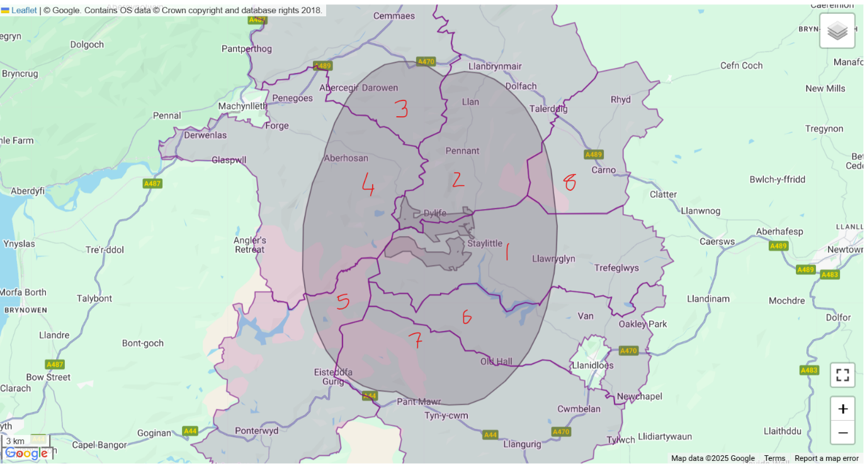

1.Trefeglwys Community Council
2. Llanbrynmair Community Council
3. Glantwymyn Community Council
4. Cadfarch Community Council
5. Blaenrheidol Community Council
6. Llanidloes – Without Community Council
7. Llangurig Community Council
8. Carno Community Council

